

**Green University of Bangladesh**

**Department of Computer Science and Engineering (CSE)**

**Faculty of Sciences and Engineering**

**Semester: (summer, Year:2022), B.Sc. in CSE (Day)**

**Course Title: Structure Programming lab**

**Course Code: CSE-106 Section:D-24**

**Lab Project Name: Restaurant Management**

**Student Details**

|  |  |  |
| --- | --- | --- |
| **Name** | | **ID** |
| **1.** | Md . Rafi Kaber | 221002498 |
| **2.** | SN Fariha Zannat | 221002474 |
| **3.** |  |  |

|  |
| --- |
| **Lab Project Status**  **Marks: ………………………………… Signature: .....................**  **Comments: .............................................. Date: ..............................** |
|  |

Table of Contents

Chapter 1 Introduction 3

1.1 Introduction 3

1.2 Design Goals/Objective 3

Chapter 2 Design/Development/Implementation of the Project 4

2.1 Restaurant project 4

2.2 Design of project 4

Chapter 3 Performance Evaluation 5

3.1 Code syntax 6

3.2 Results and Discussions 7

Chapter 4 Conclusion 9

4.1 Practical Implications 9

4.2 Scope of Future Work 9

References 10

# Chapter 1

## Introduction

My project name is Restaurant Management. In this project, I am making a purchase and sale list of Restaurant.This project is completely made by C programming with this technology we can create bills of customers coming to the restaureant.

## Design Goals/Objective

Through this project, we will be able to make a beautiful list about buying and selling in Restaurant the lists are –

1. The customer will first come to the restaurant and see a list of dishes and there will be given an idea about the food ID number price everything.
2. Now they can redeem their favorite food through their favorite number.
3. Now customer's total bill will be displayed by providing customer name and date of purchase price.
4. This name and date will be stored as history in the database of the restaurant.

# Chapter 2

# Design/Development/Implementation of the Project

* + 1. **Restaurant**

We all go to restaurant in our daily life to eat together with our loved ones family friends and many times we also go to restaurant to try new food it is a happy moment in our daily life and spend good time with our loved ones. If we can visit this favorite time beautifully with more updates and technology then our beautiful moments will be more beautiful.

## Design of the project

We have divided this project into two parts, one is for customers, the other is for sellers, so that the accounts of customers and sellers can be properly filled. And if we look at the vendors panel then there are more they can login only through a specific username and password they can't login through any other password or username this is designed to account for the restaurant owner here he sees You can see how many people visited the restaurant every day and how many people ate how much food and which food was ordered the most.

# 

# Chapter 3

# Performance Evaluation

## Code syntax

Our entire project is done through C programming and we have developed this system project using all the syntax of that programming.

Using syntax are –

* 2D Array
* Doubly Link list
* Structure
* Loop
* Function
* Switch
* String

## Results and Discussions

* + 1. **Results**

**Frist view :**

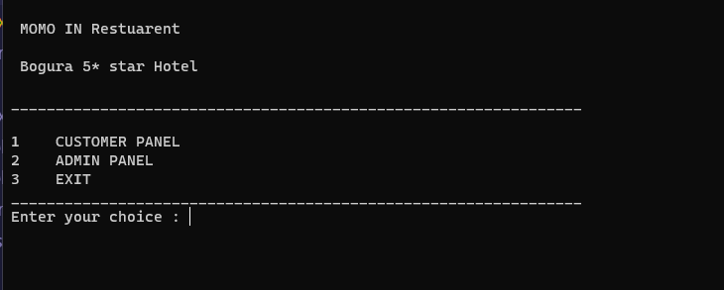

**Customer panel :**

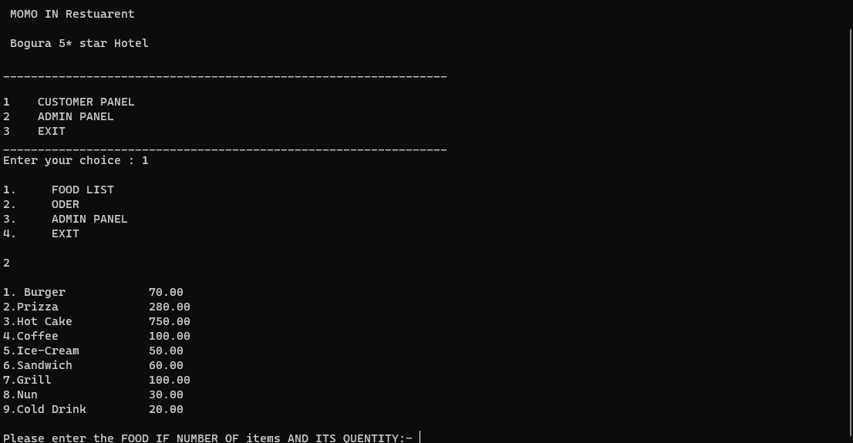

**Oder view –**

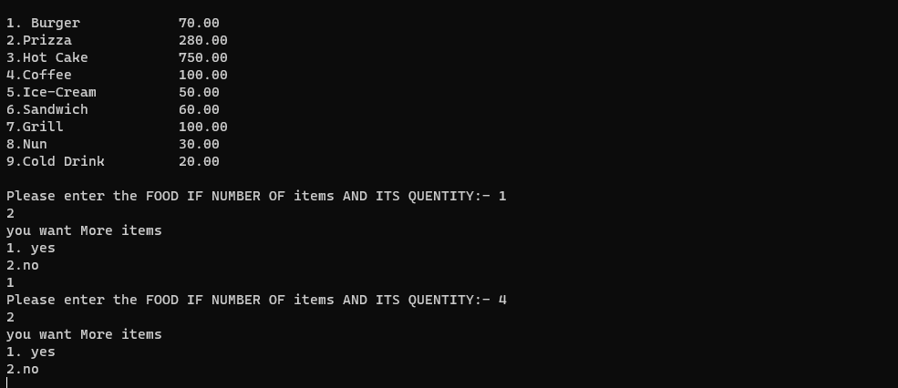

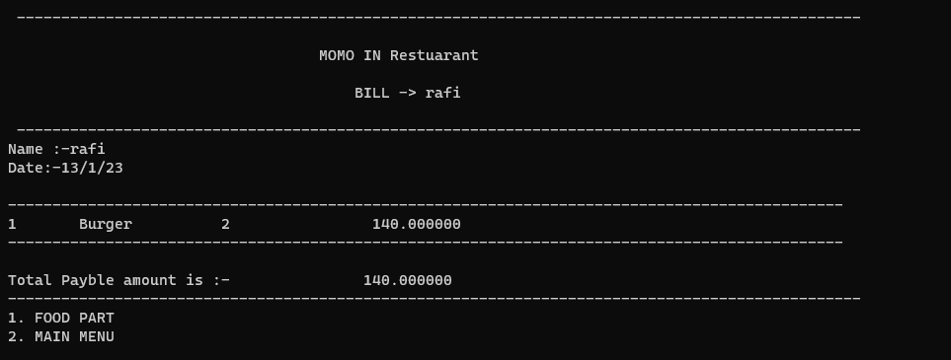**Bill view-**

**Admin panel view-**

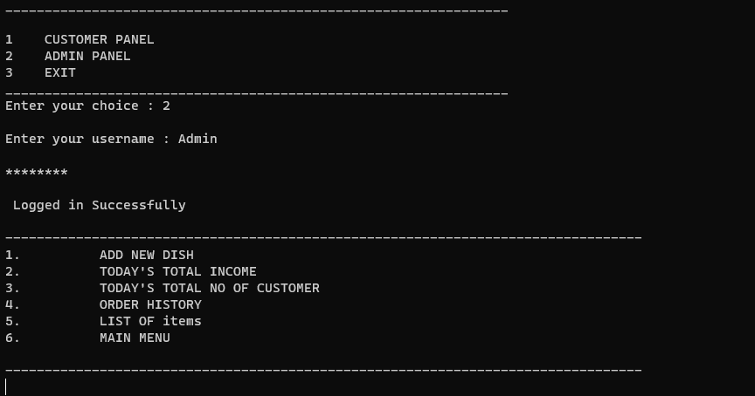

# Chapter 4 Conclusion

## Practical Implications

## We can gather all types of a restaurant through the use of this technology and who is doing more food in the restaurant, which food is more in demand and how much income we are getting and how much we should invest in our restaurant. can get and very easily lead to the improvement of his business through the use of this technology.

## Scope of Future Work

In future we can take this technology to further development like our restaurant table number and according to table number according to our token we will show him the food first by knowing the number of the person he will know how much time his food will take it will further improve our business And will lead to prosperity so that you can dine in our restaurant in a pure way.

# 

# References

1. <https://www.w3schools.com>
2. <https://www.javatpoint.com>
3. https://www.geeksforgeeks.org/java